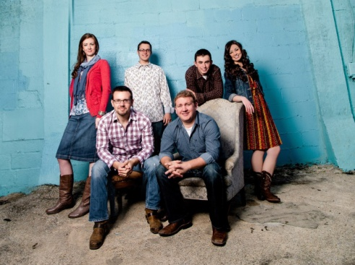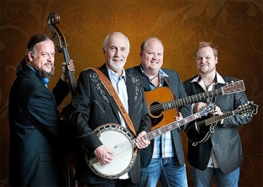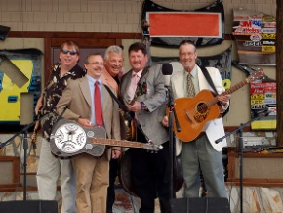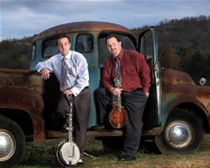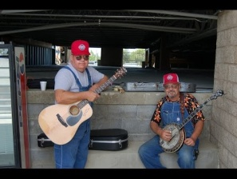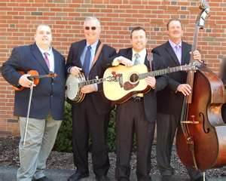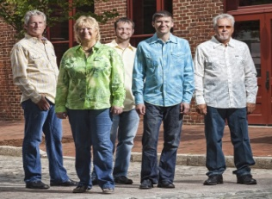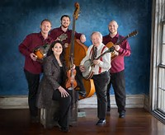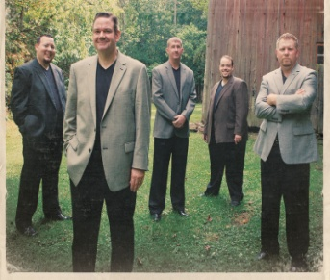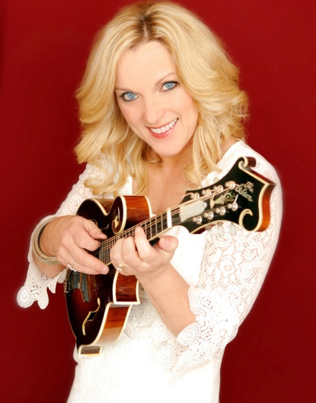

**GOLDWING EXPRESS**

(Friday, July 7)

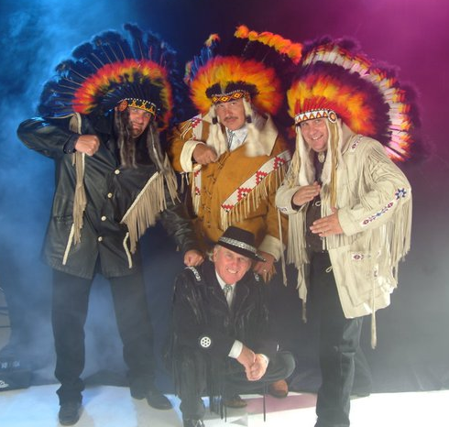

**FLATT LONESOME**

(Friday, July 7)

**RHONDA VINCENT**

(Saturday, July 8)

**By May 1st**

**$50**

**JULY 5, 6, 7, 8 & 9, 2017**

GRANGE PARK

GPS - 169 Homan Lane, Centre Hall, PA 16828

*** Featuring An All-Star Lineup & **5 Days in 2017**\*\*\*

**REMINGTON RYDE**

**BLUEGRASS FESTIVAL**

**\*\*2017\*\***

**Advance Tickets**

***GATE -- DAY PRICES (Wed 7p-10p, Thurs-Sat 10a-11pm, Sun 9a-3p)***

***WEDNESDAY -$15, THURSDAY -$25, FRIDAY -$25, SATURDAY - $25, SUNDAY-$15***

**5-day ticket @ GATE: $80**

***HOTEL SPECIAL: RAMADA INN CONFERENCE CENTER, (814) 238-3001***

***(Ask for special BLUEGRASS RATE]***

***GRANGE PARK [www.grangefair.net]***

Plenty of PARKING/HANDICAPPED Access – FOOD—SHELTER [Bring Lawn Chairs] – PETS Welcome – 24-hour security – ***CAMPING/RV*** [NO advance reservations needed - 1 free RV dump when leaving-interim pumping available - NO gray water dumping – **PAY at GATE**] – Two (2) Shower Houses, Public Restrooms & Laundry On-Site – **GOLF CARTS** allowed. **Thanks Everyone & God Bless!**

**JOE MULLINS & THE RADIO RAMBLERS**

(Thursday, July 6)

**MORON BROTHERS**

(Saturday, July 8)

**MARK TEMPLETON & POCKET CHANGE**

(Friday, July 7)

**SPECIAL CONSENSUS**

(Thursday, July 6)

**FELLER & HILL**

(Thursday, July 6)

**LORRAINE JORDAN & CAROLINA ROAD**

(Friday, July 7)

**SPINNEY BROTHERS**

(Thursday, July 6)

**FOR ADVANCED TICKETS:** Send a self-addressed stamped envelope w/ check or money order made payable to ***REMINGTON RYDE, 604 Iron Springs Rd, Hummelstown, PA 17036* (please, ALL CAMPING PAID @ GATE)**

ADVANCE TICKET PRICES [RAIN or SHINE - NO REFUNDS

**EARLY BIRD RATE: 5-day advance # of tickets ______ x $50 (BY MAY 1)**

**5-day advance, # of tickets ______x $60 (by JULY 1)**

NAME: _______________________________________________________

ADDRESS: _____________________________________________________

CITY: _______________________STATE: _________ ZIP _______________

EMAIL ADDR: ________________________________________________________

CONTACT: **Ryan Frankhouser @ 717.348.3537** – www.remingtonryde.com

**LITTLE ROY & LIZZY SHOW**

(Thursday, July 6)

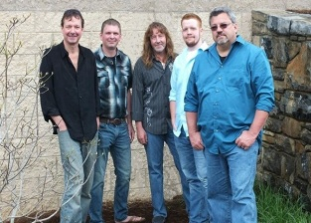

**NOTHIN FANCY**

(Friday, July 7)

**REMINGTON RYDE**

(Wednesday, Thursday, Saturday, Sunday)

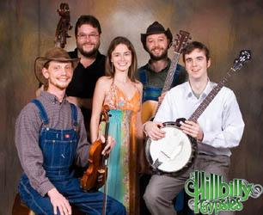

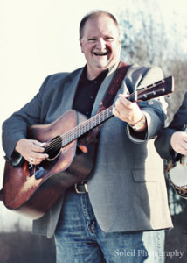

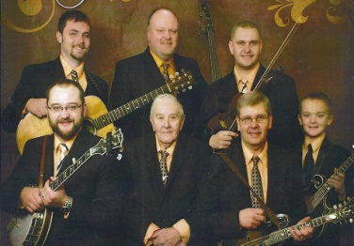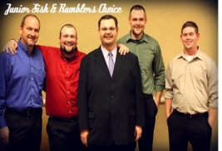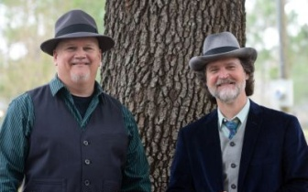

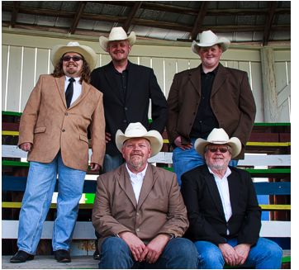

**US NAVY BAND**

(Saturday, July 8 Tentative)

**LARRY EFAW & THE BLUEGRASS MOUNTAINEERS**

(Friday, July 7)

**DANNY PAISLEY**

(Sunday, July 9)

**JR. SISK &**

**RAMBLERS CHOICE**

(Saturday, July 8)

**BLUEGRASS BROTHERS**

(Thursday, July 6)

**HILLBILLY GYPSIES**

(Wednesday, July 5)

**KIP & JERRY’S ROCKY**

**ROAD SHOW**

(Saturday, July 8)

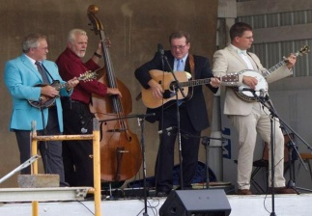

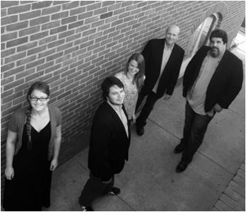

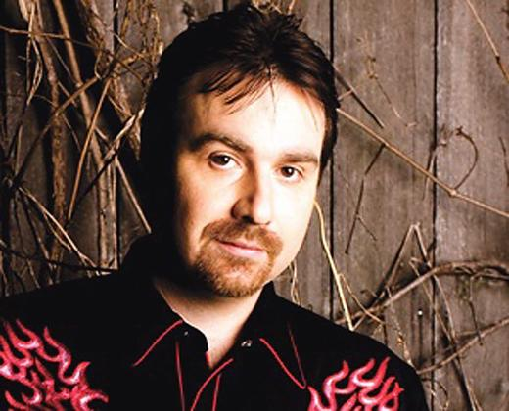

**\*\*1500 RV Hookups\*\*** (30amp Electric & Water)

Camping: 4 or more days-$20/day; 3 or fewer-$25/day

[Gates Open On Sunday July 2nd @ Noon --- PAY AT GATE]

**CIRCA BLUE**

(Sunday, July 9)

**Ralph Stanley II**

(Friday July 7)

**VIRGINIA RAMBLERS**

(Saturday, July 8)